# Roles:

Cecilia: Business and advertisement song

Noah: External device and long-term application

Will: Motor attachment and case

Thomas: Physical device and short-term application

Toni: Design of vent thing and marketing designs

Tvisha: Video advertisement

# Brainstorming:

#### Ideas

Beach safety

* App, scroll, button
* Trash, beach density, turtle hatching, weather
* Enjoyment level stars

Crab breeding ID cards

* Promoting repopulation
* Eliminating waste

Agriculture

* AI on this
* Is this possible?

Inconvenience like black box systems or having to turn something on to read something

Medical diagnoses percent, options like heart attack, stroke, ocular disease recognition -> display the percentage of likelihood

# Plans:

#### Company Name:

Sustainable Vents

#### Slogan:

Saving the world and your electricity bill one vent at a time

#### Device Name:

Ecovent 1.20

#### Dimensions:

23 cm x 17 cm x 6 cm -> box

#### Video Ideas:

* Hot with big fan scene
* Cold with blanket vine
* Money from the wallet into vent
* 80s informatic

#### Device Goals:

Short term: make HVAC systems more energy efficient

Long term: User awareness

#### Timeline:

Build actual device on Thur 19

Program by Sun 22

Prototype motor attachment and box by Mon 23

Plan video out by end of Mon 23

Have all the non-stupid stuff filmed by Thur 26

Film stupid stuff with freshmen at activity fair on Thur 26

Edit video and submit Fri 27

#### Device Idea:

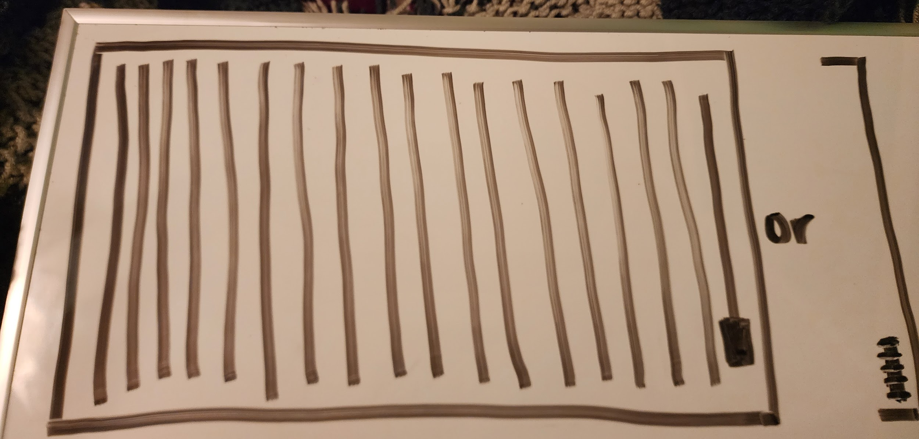

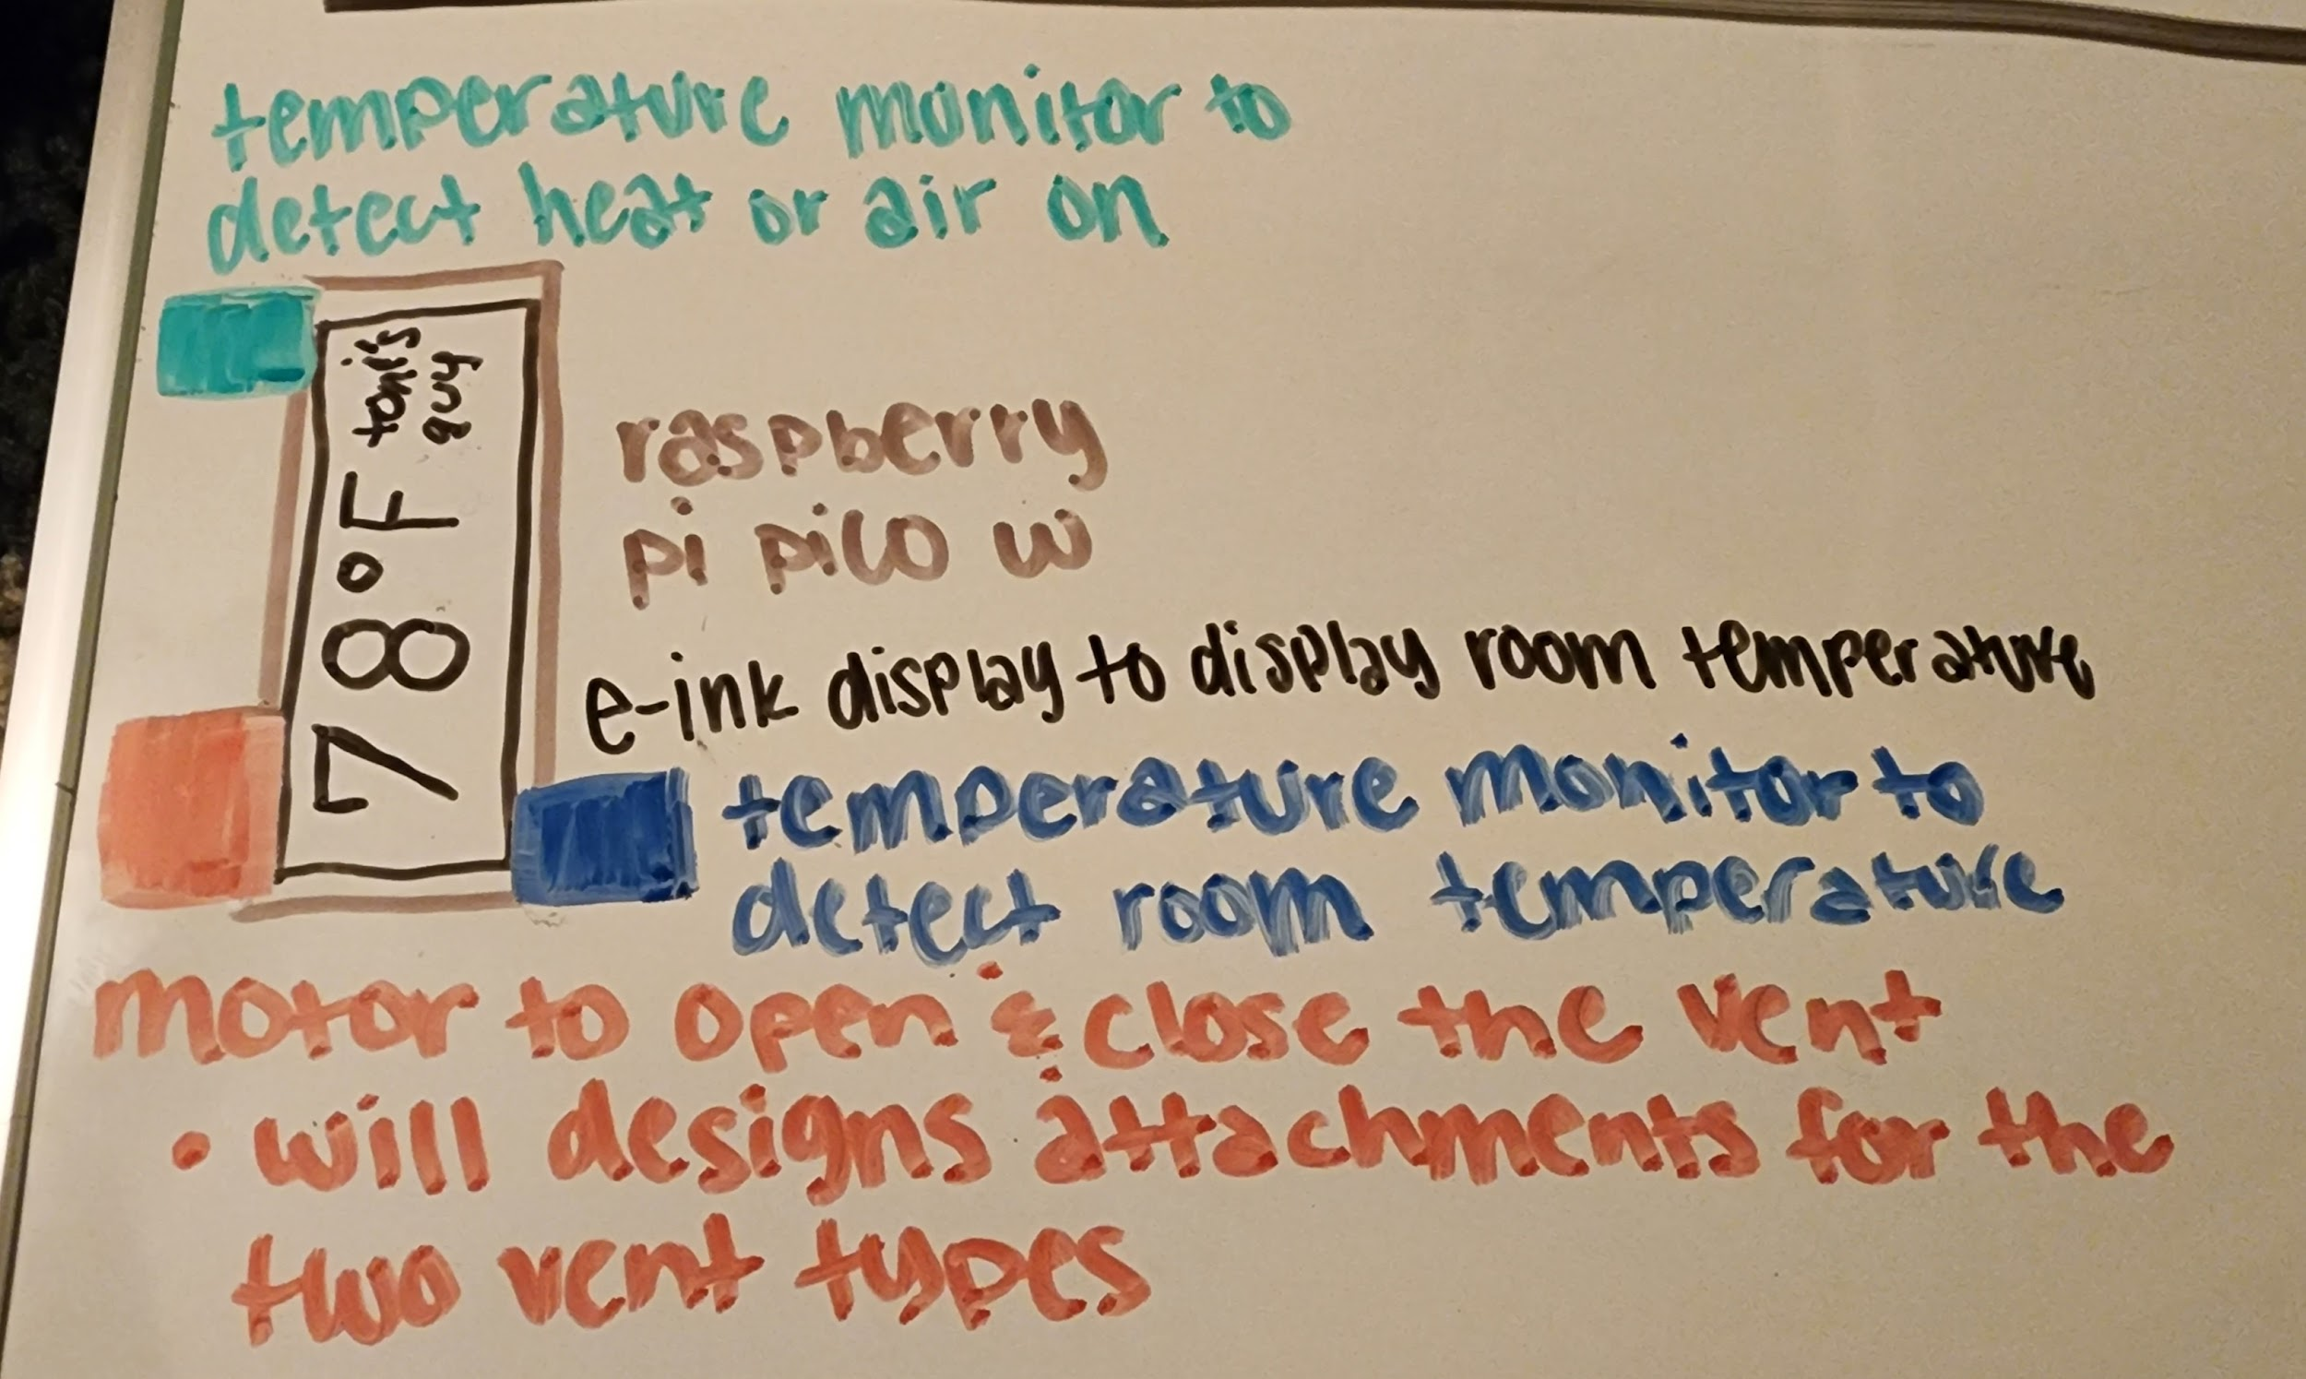

#### Memories:

